**The Derelict Wanderer: ‘Hildebrand’**

Kristoffer Pauly (Dosei-desu):

<https://github.com/Dosei-desu/AdventureGame>

Martin Ejlersen (Wienerbroed):

<https://github.com/Wienerbroed/MartinAdventure>

Søren Rasmussen (SeveriusRasmussen):

<https://github.com/SeveriusRasmussen/OwnAdventureExercise>

Klassediagram:

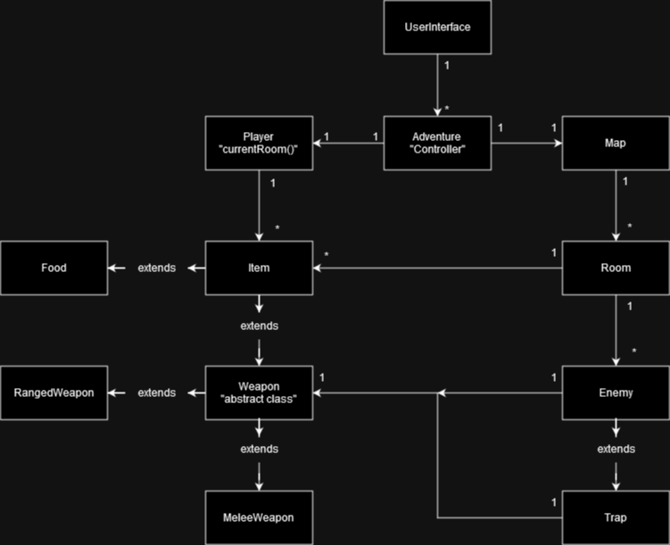

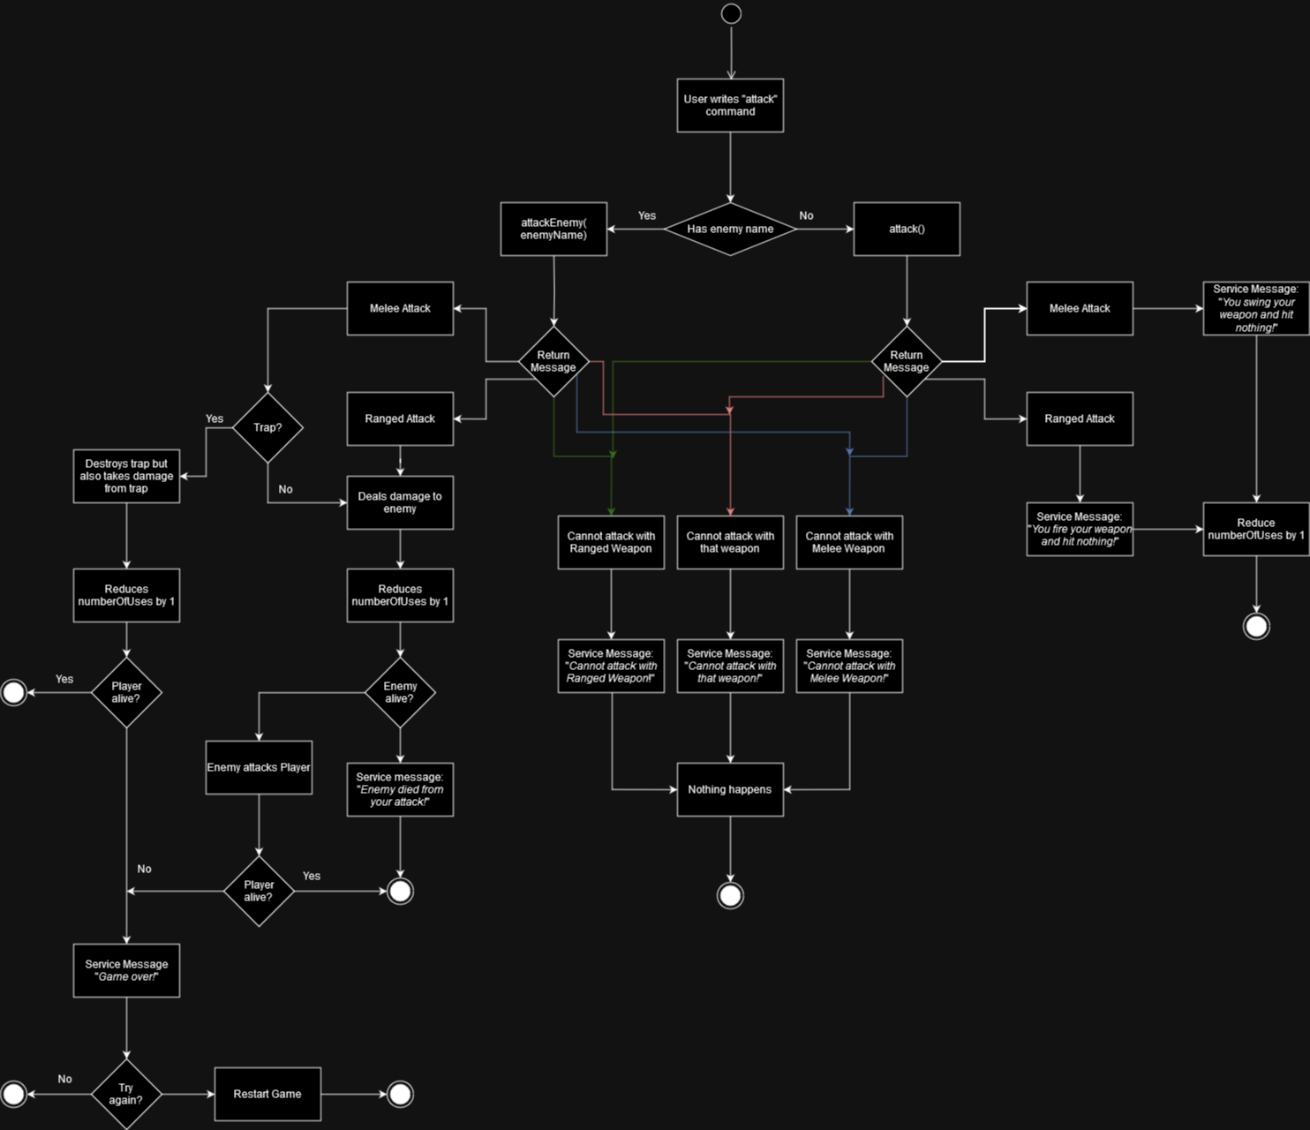Aktivitetsdiagram over “Attack()” metode: